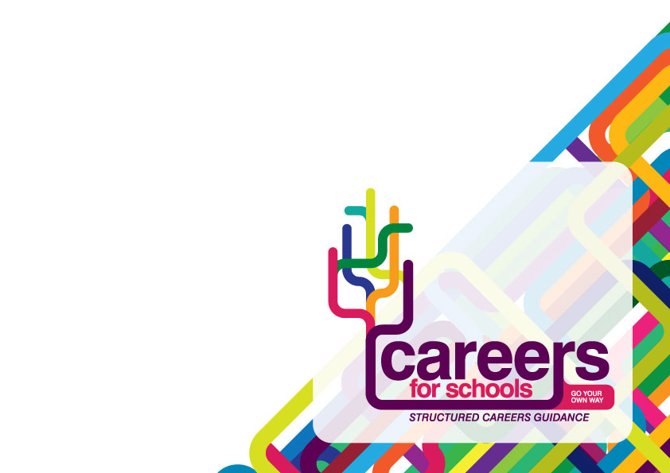
GUIDANCE FOR STUDENTS

Stage 1: RESEARCH

- Login to Careers Planner

- Open ‘My Documents’ (top right of the screen)

- Open ‘My Personal Statement’ and familiarize yourself with the different sections on this home page.

- Click ‘Get Started’

- Click on the link to ‘My Personal Statement Mindmap’, read this carefully before you start and create your own mindmap.
- Click on the link to ‘My Personal Statement Timeline’ and note all of the key deadlines.
- Click on the ‘Video Introduction’ link and listen to the admissions tutor from Imperial College, London (This is a long video but it is packed with useful advice and ideas)

- Click on the Careers Planner icon (top left of the screen) – this takes you back to the Careers Planner home page. Go to ‘How do I find out more about university?’ > ‘How do I apply?’ > Personal Statement. Here you can access a range of resources to help you understand how to write your personal statement, including examples of personal statements.

Stage 2: WRITING YOUR PERSONAL STATEMENT

- Select ‘Opening Statement’ from the menu bar. Read the guidance notes and draft your
opening statement. Click the ‘Save and Next’ button – you can change or update your draft
each time you visit this section.

- Advice and Support - you can send your draft to your tutor by clicking the ‘Submit
for Comment’ button. Your tutor will be then be able to view your
draft and send you some feedback via the email address you used
to register for Careers Planner.

- Select each of the other sections from the menu bar and repeat
the process described above.

- Select ‘My UCAS Personal Statement’ from the menu bar and
view the full document.

- Submit the final draft to your tutor for feedback.

