September 16th 2020

Dear Parents and Carers

It is with great delight that I write to you and thank you for the tremendous support that you have shown which has enabled us to facilitate an extremely successful return to school. Teamwork has been key. Teamwork amongst parents, students and staff. The students have embraced the changes and we should be very proud of our amazingly resilient young people.

They have:

- Navigated the new entrances and exits to school
- Washed their hands as they enter their bubbles
- Embraced these new systems
- Lined up in silence and in alphabetical order in their bubbles before entering the building
- Embraced wearing facial coverings in all internal communal areas
- Walked in silence on the left in communal areas
- Sanitised their hands as they entered and exited classrooms
- Learnt with adults teaching from the front of the room
- Shown patience when queuing to visit the toilet

My heartfelt thanks go to you as parents who have supported the school and talked through the new challenges with your child.

As promised at the outset, we will review the new systems by the end of week three. Currently our priority is to commence a hot lunch provision, we are investigating how this can be done safely and will update you accordingly.

We are continuing to monitor and challenge the parents who persist in dropping their child off on the exceptionally busy Kenton lane, Moor Lane and cottages by the PROW. I need to continue to remind parents not to do this as you are risking the safety of students by, often, reckless parking. To guarantee the safety of our students we need you to make alternative arrangements when dropping your child off by car or taxi.

Thank you to all parents who have ensured that their children have all the equipment they need before they leave for school as we are unable to accept drop offs of equipment or uniform at the school or at the school gate due to Covid-19 restrictions.

In order to ensure we are capturing both your views and your child’s views I have set up questionnaires for you to complete and where your responses will help forge our review of the opening plans. The links to the questionnaires can be found at https://www.kenton.newcastle.sch.uk/copy-of-letters-for-parents. The deadline for responding to the questionnaires is Friday 25th September 3pm.

To conclude, we have all come a long way through this pandemic and of course we have further to go, but I can honestly say that it really is a joy to have the building filled again with the wonderful students and staff of Kenton School.

Yours sincerely
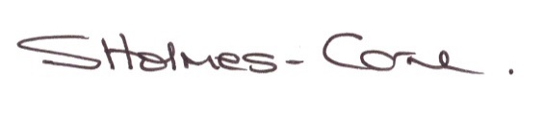
Sarah Holmes-Carne
Principal

