Using the Citizen’s Portal to apply for Free School Meals

From your home page, click on “Apply for Free School Meals”

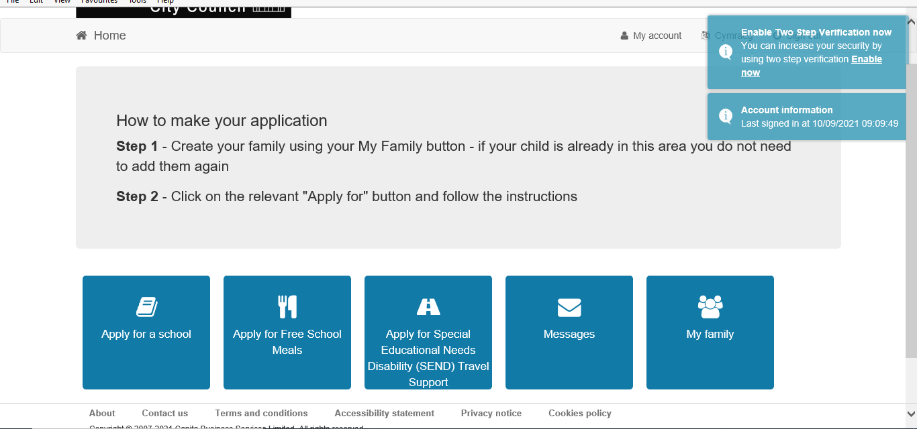

You will be given an option to start a new application (or if you have already applied, to continue an application). Click on this button.

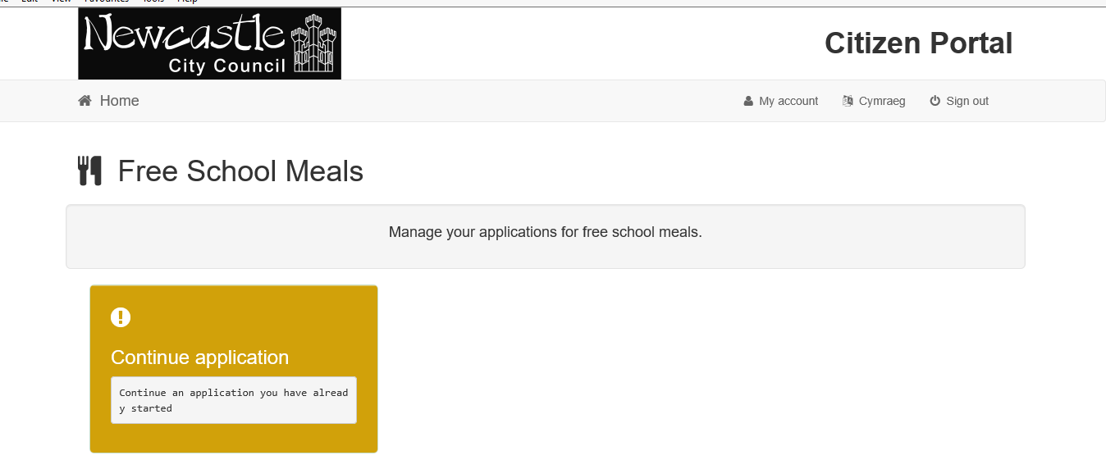

Step 1 - Enter your details on the form, choose which children to include in your application or add a new child.

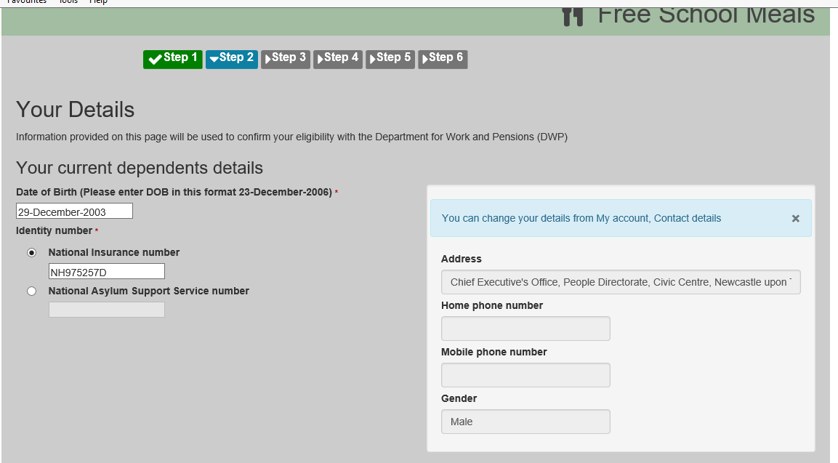
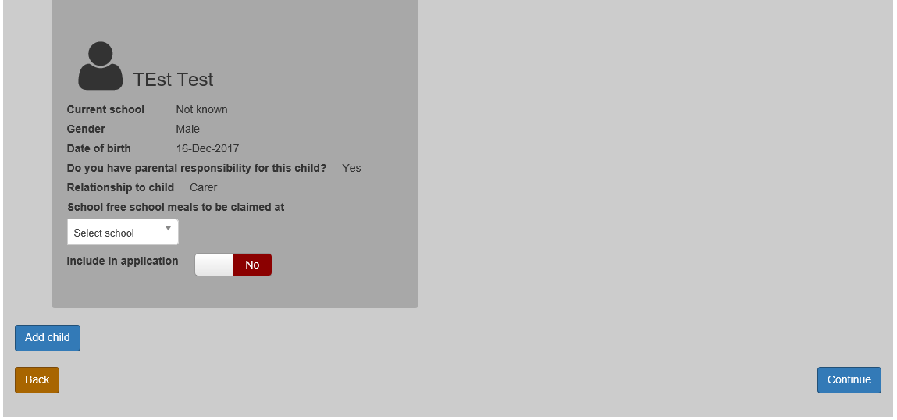

Step 3 - Let us know if your children were previously on free school meals in another local authority so we can check if you have protection.

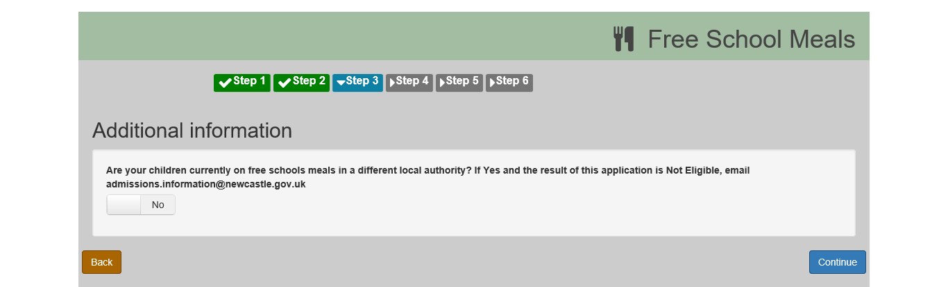

Step 4 – Check the details are correct

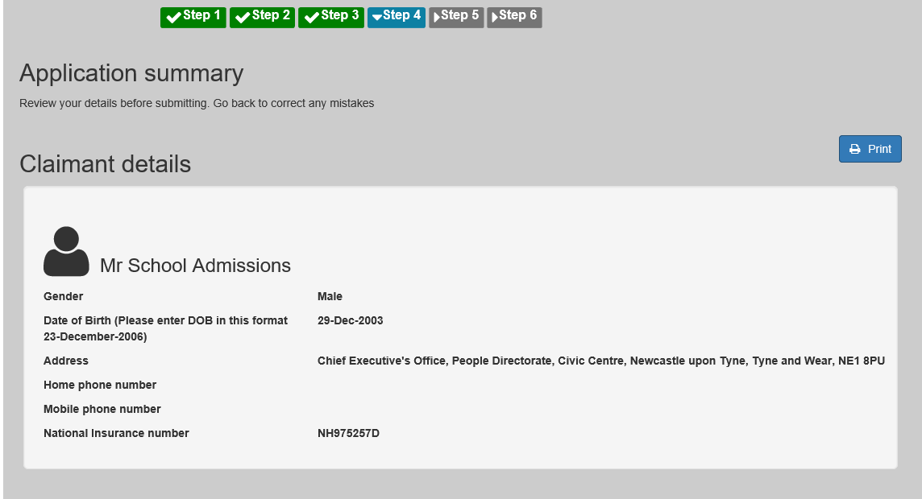

Step 5 – tick the box to confirm you agree to the declaration and click accept

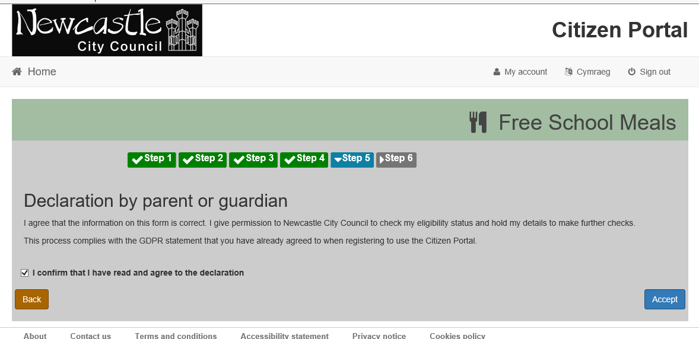

Step 6 – your results. Usually this will tell you that you are eligible or not. Sometimes it will ask you to check your details (this may be because you have mis-spelled something or the Department of Work and Pensions has slightly different information on you, such as a previous surname.) You will also receive an email.

If you receive a “not eligible” response but believe you do meet the criteria, contact admissions.information@newcastle.gov.uk who can complete a manual application

