Kenton School
Policy Documentation
Policy: Teaching & Learning
Responsibility for Review: Assistant Principal for Teaching and Learning
Academic year 2021-22

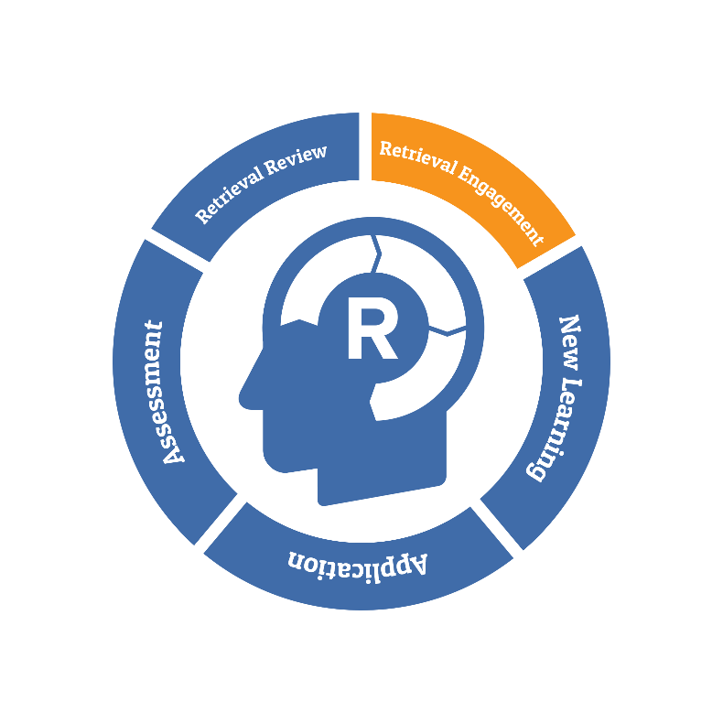

- Aims
Teaching and Learning is at the heart of all we do. Our aim is to deliver outstanding teaching that enables outstanding learning for all students, so that knowledge is embedded, and disadvantage is not a barrier. We want all our students to reach their potential, so that they are well placed for life beyond school. We aim to ensure confident, happy and resilient students, who treat others with compassion and respect. We have high expectations of our learners and therefore the quality of teaching that they receive. We aim to see measurable impact of high-quality teaching in the outcomes and attainment of our students at incremental stages in their school year as well as in public examinations at the end of Key Stages 4 and 5. At Kenton School we firmly believe that:
- Every student is entitled to high quality teaching, irrespective of educational and social needs and no matter what their entry level.
- Every lesson should be engaging, full of new learning opportunities as well as building on and retrieving prior knowledge.
- Every student should be stretched and challenged to the appropriate level to ensure that their potential is reached and to allow them to compete with their peers around the country.
- Student independence and resilience should be developed at every opportunity so that they develop a whole host of problem-solving strategies.
- Every classroom will reflect our core beliefs and values and lessons will reflect our belief in retrieval theory and the explicit teaching of vocabulary.
- The professional development of all staff is central to our aims. A bespoke Professional Learning Programme has been developed to allow teachers to develop their pedagogy of explicit teaching strategies.
- Teachers will model high quality meta-cognitive oracy and literacy and constantly elicit fully extended responses from students in order to close the vocabulary gap.

- Expectations

- Planning
All teachers are expected to plan lessons for the classes they teach using the Kenton Learning Cycle (KLC), ‘topping and tailing’ learning with ‘retrieval’ and ‘review’ activities. Lessons should adapt the scheme of learning that accompanies the topic to suit the needs and starting points of the learners in their class. Should lessons be pre-set in departmental areas it is the teacher’s responsibility to review in advance and alter as necessary to suit the class being taught. Particularly successful tweaks should be shared with colleagues who can add this to their repertoire at a future date. Sequences of learning should reflect the day to day planning that teachers do, reflecting on what has worked in the lesson or what was unfinished and needs reviewing in the next lesson. Staff must also be aware of the most up to date data; seating plans must be carefully considered; any SEND information must be adhered to; and the EEF Quality First Teaching strategies are to be employed where appropriate, particularly regarding our Pupil Premium students.
- Marking and feedback

We expect all feedback and marking to be manageable, meaningful and motivating and used to offer students opportunities to progress whilst informing teacher planning. EEF research places feedback to students as one of the most cost-effective ways to improve student outcomes. We work on the principle that the first piece of work produced by a student at the will be the weakest and from there work should improve and progress should be clear. At the start of every term work needs to be marked within the first two weeks and challenged for both school and departmental expectations to ensure no regression.
Formative feedback and opportunities for students to respond should be as follows:

- Core subjects 4x per term
- EBACC subjects 3x per term
- Non EBACC (inc. Art) 2x per term
- Technology KS4/5 follow the guidelines from the exam board

We are currently experimenting with increasing the frequency of live marking and the use of whole class marking.

- Teaching and Learning Model
Teacher are expected to use the Kenton Learning Cycle to plan and deliver lessons. A structured learning cycle is proven to help disadvantaged learners and teachers must share the ‘why’, ‘when’, ‘how’ of learning by verbalizing the cycle with their classes. The KLC is also a structured way for staff to reflect upon and learn from their experiences, promoting the investigation of new ideas and sharing of good practice with colleagues. The KLC is split into five distinct stages:
- Retrieval of prior knowledge (in silence)
- New Learning
- Applying Activity
- Anytime assessment
- Review the lesson
The ‘retrieval’ and the ‘review’ sections of the lesson (topping and tailing) will continue to focus on retrieval theory – challenging students to retrieve knowledge from previous days, weeks and months; the review section challenging students to remember exactly what has just happened in the particular lesson. This strategy of ‘retrieval’ is firmly embedded in seminal work on memory by Ebbinghaus.
We believe that our teachers are the experts in the room and that they will be allowed to explicitly teach their subject through modelling tasks, scaffolding work, assessing at any time and through cold-call questioning, thereby creating a fully inclusive and effortful learner experience.
- Quality Assurance
We have a robust system in place to ensure that we retain high quality and consistency in our expectations across the curriculum. This is led by the Assistant Principal for Teaching and Learning and is supported by the senior and middle leadership team. As well as Departmental QA which is carried out by SLT, HODs and TLR holders, including walkthroughs, book scrutinies and student voice the school Principal and Headship Team carry out systematic QA days. These focus on a number of students from a particular year or target group. An extensive book and planner scrutiny, student voice and walk through observation takes place over the school day. The Headship Team meets to share their findings and to create an appropriate action plan to maximise the progress of the students. SLT also have a rigorous Department Work Scrutiny Programme spread over the academic year. During these, SLT will QA the departments’ scrutiny providing feedback to the TLR team. Outstanding practice can then be disseminated within and across departments and line managers can follow up any need to improve the quality of marking and feedback.

- Homework

According to trusted research from the EEF there is an average 5 month gain in progress through effective use of homework. To this end we have now put all our homework onto Microsoft Teams where we use multiple choice quizzing to review prior learning. Due dates are still printed in student planners. Students are expected to complete their homework tasks every day, parents have been informed of how they can help and every task is set to challenge students to ‘retrieve’ and build on prior learning.

- Professional Development

  - We now use a Teaching & Learning audit to allow teachers to set their own appraisal targets based around the key ingredients of our whole school priorities.
  - Formerly a DFE pilot school for Early Years Retention we are now signed up to the Early Career Teacher programme (ECT) and so teachers in their first two years of teaching all have coaches with a ring-fenced one hour a week remission on timetables to work on appropriate targets with Ambition Institute.
  - Subject departments are given 15 slots of CPD per year to develop and enhance teacher expertise and subject knowledge at a departmental level.
  - One Vision opportunities means that National Leaders and Specialist Leaders of Education will be working with Kenton SLT and core and EBacc middle leaders to help embed a consistent approach to teaching and learning throughout the school.

- Kenton Learning Zone (KLZ)

All school ICT is being migrated onto what we call the KLZ. This is a one-stop area for staff and students alike in which all resources, learning journeys, homework, knowledge organisers, class Teams can be found.

Our priorities for 2021-22:
