September 10th 2020

Dear Parents and Carers

I wrote to all parents and carers several times prior to the school reopening each time requesting that all students are encouraged to walk, cycle or take a bus to school. That we wanted to minimise the risk of Covid 19 by reducing the number of vehicles on site. The reason for this is that we will have pupils from various different year groups coming into the car park at any one time which of course defeats the object of pupils having their own bubbles and their own gate access.

The letters can be found https://www.kenton.newcastle.sch.uk/copy-of-letters-for-parents

I respectfully ask again that parents exhaust every possible option of their child travelling to and from school before resorting to transport by car. This both supports the Covid 19 school risk assessment and also supports Newcastle City Council aims to reduce carbon emission across the city.

It is very important that if, as a last resort, you need to use the car to transport your child then you must not park on Moor Lane (opposite the school) or anywhere near the houses at the top end of the Public Right of Way opposite the nursing home on Kenton Lane. The Police can issue a fixed penalty notice for blocking a drive way, path or private road even for a short amount of time. Please can we respect the occupants of the houses around the school?

On Wednesday many vehicles parked on Moor Lane and private drives next to the PROW and despite a heavy Kenton School staff presence there were serious concerns pupils could have been hurt in a road traffic accident. Additionally many of our neighbours who live on Moor lane were blocked in. I have written a letter to the residents apologising for the inconvenience they experienced.

We have taken the very difficult decision to identify an area within the school site to provide a safe drop off point. This will need to be managed carefully to avoid an increases in risk of COVID 19.

I have enclosed a map with instructions on how to access the site and where to drop your child off, with instructions on how your child moves to their bubble gate, but I cannot stress enough please only transport your child in a car as a last resort.

Yours sincerely
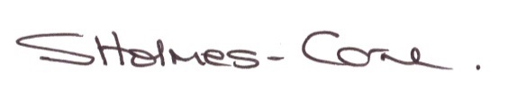
Sarah Holmes-Carne
Principal

