Monday 12th July 2021
Dear student,
We have reached the end of this difficult year and there are no doubts we have been able to navigate the Covid challenges with the full support of all parents. The students in Year 12 have risen to the expectation of Covid regulations and as I have stated on numerous occasions, I am so proud of each and every one of them.

Please can we update you on some minor changes to your child’s form tutor for September 2021.

Year Leaders: Ms L Philson Assistant Principal: Mr S Ord
Form Tutor 2020-21 | Form Tutor 2021-22 | Contact Details
CA/TF | Mrs Atthey  Ms Walker | Claire.Atthey@kenton.newcastle.sch.uk  Kay.Walker@kenton.newcastle.sch.uk
ALO/NV | Ms Lockhart  Mrs Ladha | Angela.Lockhart@kenton.newcastle.sch.uk  Andrea.Ladha@kenton.newcastle.sch.uk
DBO/AH | Mr Hicken | Andrew.Hicken@kenton.newcastle.sch.uk
CMC/ET | Mr McCaw  Miss Turner | Christopher.McCaw@kenton.newcastle.sch.uk  Emma.Turner@kenton.newcastle.sch.uk
CCR/SRT | Ms Ritson  Miss Crawford | Sophie.Ritson@kenton.newcastle.sch.uk  Catherine.Crawford@kenton.newcastle.sch.uk
LJC/BD | Mrs Cox  Mrs Dawson | Laura.Cox@kenton.newcastle.sch.uk  Becky.Dawson@kenton.newcastle.sch.uk
RJM/RSW | Mr Macfarlane  Mrs Swinhoe | Robert.Macfarlane@kenton.newcastle.sch.uk  Rachael.Swinhoe@kenton.newcastle.sch.uk
RED | Mrs Elliott-Downing | Rachel.Elliott-Downing@kenton.newcastle.sch.uk

If you wish to contact Mr Ord please do so via Stephen.ord@kenton.newcastle.sch.uk

Please note the first day for students is Wednesday 8th September 2021.

Other key dates for the year can be found on the calendar on the school website at https://www.kenton.newcastle.sch.uk/calendar.

Year 13 and next steps
All students should now be registered on the UCAS Hub. This allows them to plan for university, apprenticeships or employment opportunities and make sure they are best placed for support going into 2021/22. Please do have conversations regularly with students about their plans for beyond Year 13, we are providing as much information as we can but you know your children best.

The students will have sat PPEs (pre-public exams) during the penultimate week of term, these are to be used as indicators for Year 13 so students should be treating them seriously. We also need to identify any gaps in learning from the time between January and March, so that we can eradicate these as soon as possible.

University applications
Please be aware that for those students applying to university there are two separate deadlines. For those students applying for medicine, dentistry, veterinary studies or to Oxford or Cambridge the deadline for applications is the 15th October at 6pm. I am delighted that we currently have seven students planning to apply via this route.

Any other applications will need to be completed by 26th January at 6pm. Your young person will be supported by their form tutor in providing a personal statement and an academic reference. There will also be additional support from Ms Philson and Mr Ord in ensuring that all applications can be sent off on time. Earlier application does increase the opportunity for more advantageous offers, so those students with a January deadline should still consider submitting in November 2021.

Results from 2021 exams
Earlier in the year we wrote to you and produced a video indicating the evidence that could be used when determining your Teacher Assessed Grades. Following completion of final assessments and a rigorous moderation and meeting process we are able to confirm the evidence used in each subject. You can find full details of our Centre Policy for awarding grades this summer in the news section of the school website. The process detailed in our policy has been approved by the Joint Council for Qualifications.

Course | Evidence used
GCSE English Language | Final Assessment
GCSE Mathematics | Final Assessment

For students with these examination results to collect in August they will be available on Thursday 12th August. They will be available from outside the Main Hall and will be available from the Sixth Form desk that Mr Ord and Ms Philson will be at.

Your results belong to you (the candidate) and you should collect your own results from School in person. Someone else, eg your parents, may collect your results for you but ONLY if they bring with them an original paper letter signed by yourself giving your permission and their own photo identification.

Under no circumstances are we allowed to give out results over the telephone or text.

Finally, I hope all families are able to enjoy the summer break. I know it has been a long, hard fifteen months but I would like to thank you for your continued support of the school and ensuring our students have a successful 2021/22.

Yours sincerely,
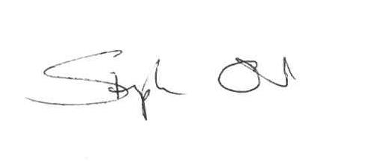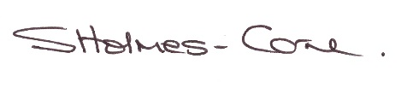
Stephen Ord Sarah Holmes-Carne
Assistant Principal Principal

